GNR644 REMOTE SENSING FOR SURFACE WATER RESOURCES
GROUP 2
ROLL NUMBER | NAME
25M0304 | SATYENDRANATH KAR
25M0611 | RISHI GANESH L
25M0612 | JAGU MANISH
25M0614 | MINTI JASAKIYA

STUDY AREA: Peninsular India
TIME SERIES ANALYSIS:
The following analysis that had been performed for all the hydrological variables used for water balance study are:
- Basic Temporal Analysis:
  - Time Series Analysis of Mean of the Basin
  - Monthly Temporal Variation Analysis throughout the period
  - Trend Quantification
- Advanced Temporal Analysis:
  - Pixel Wise Trend Using Mann Kendall Test
  - Correlation Matrix
  - Temporal Lag Correlation

BASIC TEMPORAL ANALYSIS:
The temporal and monthly plots in the table below show clear seasonal changes in the hydrological components from 2000 to 2024. Precipitation has strong monsoonal peaks between June and September. These peaks drive increases in soil moisture and runoff during the same period. Soil moisture responds quickly to rainfall, showing higher levels in the monsoon months and lower levels in the dry season. Runoff peaks shortly after heavy rainfall, indicating a quick surface flow response. Evapotranspiration increases during warmer and wetter months because of higher water availability and atmospheric demand. Groundwater rises later in the season after the monsoon, reflecting recharge through infiltration. Overall, the plots illustrate a consistent seasonal hydrological cycle primarily influenced by monsoon precipitation.

Variable/ Analysis | Time Series Analysis of Mean of the Basin | Monthly Temporal Variation Analysis throughout the period
Evapotranspiration | 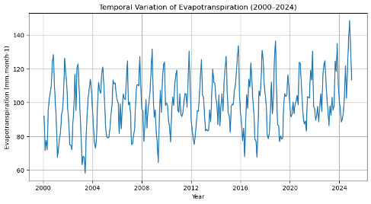 | 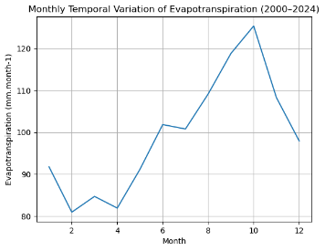
Soil Moisture | 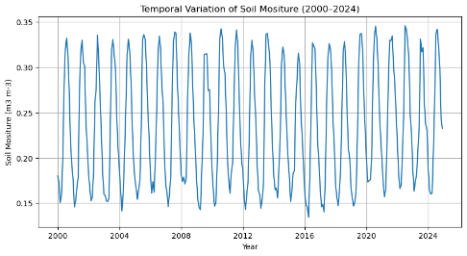 | 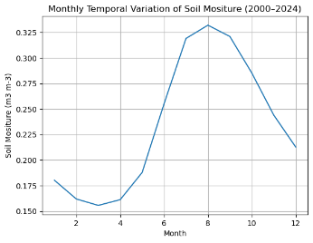
Runoff | 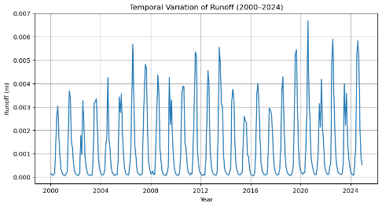 | 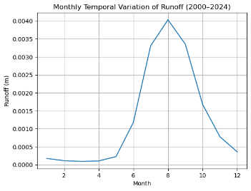
Groundwater | 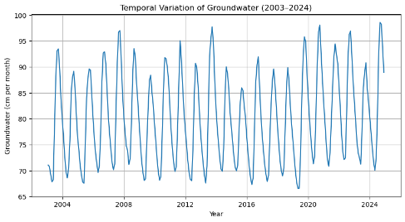 | 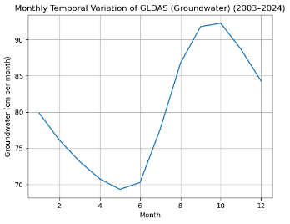
Precipitation | 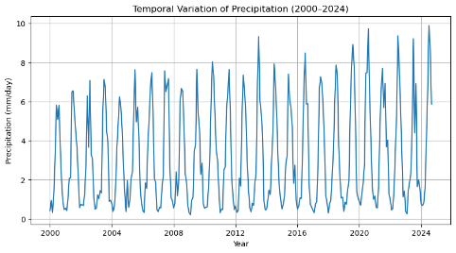 | 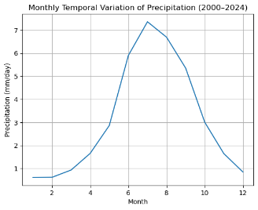

TREND QUANTIFICATION:
The trend analysis shows different long-term changes in the hydrological variables. Evapotranspiration (ET) has a clear increasing trend (slope ≈ 0.039, p < 0.001). This suggests a steady rise in atmospheric water demand or surface water availability during the study period. Groundwater (GW) also has a statistically significant increasing trend (slope ≈ 0.014, p ≈ 0.048), which indicates gradual improvement or recharge in groundwater storage. Precipitation (PP) has a weak positive trend (p ≈ 0.051), suggesting a slight increase, but it is only marginally statistically significant. Runoff (RO) shows a small increasing trend, but it is not statistically significant (p > 0.05). Soil moisture (SM) remains relatively unchanged, with no significant trend, indicating stable soil water conditions over time.

ADVANCED TEMPORAL ANALYSIS:
MANN KENDALL PIXEL BY PIXEL TREND ANALYSIS:
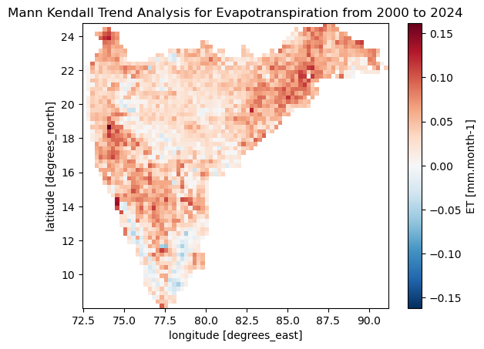 | 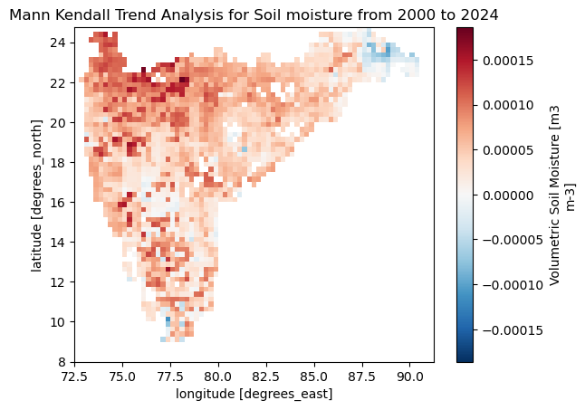 | 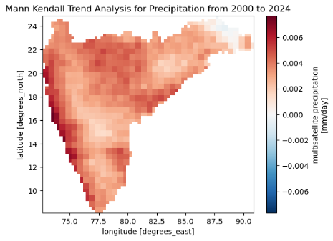
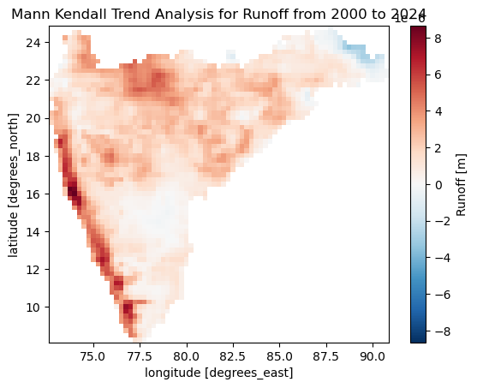 | 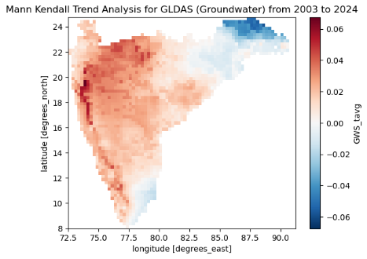
The Mann-Kendall trend maps show how hydrological changes vary across the study area. Evapotranspiration generally rises in most places, especially in the central and eastern regions. This suggests that atmospheric water demand is increasing or that there is more moisture available on the surface. Soil moisture mostly has weak positive trends, with some localized decreases in the southern and northeastern areas. This indicates that soil water conditions are relatively stable but unevenly distributed. Precipitation tends to increase overall, particularly along the western coastal belt, which reflects stronger rainfall patterns. Runoff trends are mainly positive in the western and central regions, matching the higher precipitation. Groundwater storage trends are up in the western and central areas, while some parts of the northeast show slight declines. This highlights the differences in groundwater recharge and dynamics across the region.

CORRELATION MATRIX:
Variables | ET | Soil Moisture | Runoff | Groundwater | Precipitation
ET | 1 | 0.72 | 0.51 | 0.69 | 0.41
Soil Moisture | 0.72 | 1 | 0.89 | 0.63 | 0.84
Runoff | 0.51 | 0.89 | 1 | 0.53 | 0.85
Groundwater | 0.69 | 0.63 | 0.53 | 1 | 0.16
Precipitation | 0.41 | 0.84 | 0.85 | 0.16 | 1

The correlation matrix shows the relationships among key hydrological variables. Soil moisture has strong positive relationships with precipitation (0.84) and runoff (0.89). This means that rainfall quickly raises soil water content and increases surface runoff. Runoff also has a strong connection with precipitation (0.85), showing an immediate hydrological response during rainfall events. Evapotranspiration (ET) is moderately linked to soil moisture (0.72) and groundwater (0.69), indicating that water available in the soil and underground supports evapotranspiration. Groundwater shows a relatively weak connection with precipitation (0.16), meaning recharge happens later through infiltration and percolation. Overall, the correlations illustrate a clear hydrological pathway where precipitation affects soil moisture, runoff, ET, and groundwater dynamics.
TEMPORAL LAG CORRELATION:
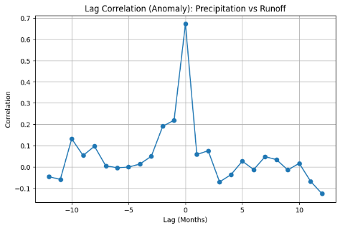 | 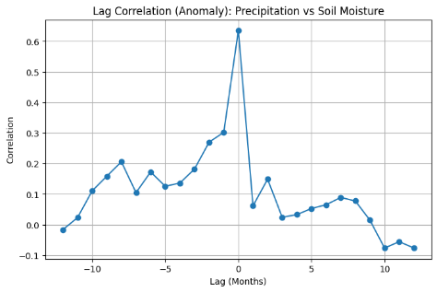 | 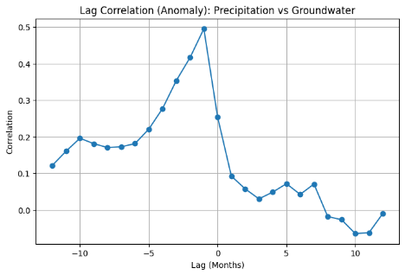
The lag correlation analysis based on de-seasonalized anomalies helps explain how different hydrological components respond to rainfall over time. The results show that precipitation and runoff have the strongest correlation at zero lag (~0.67), indicating that runoff responds almost immediately when rainfall occurs. A similarly strong correlation is observed between precipitation and soil moisture at zero lag (~0.63), suggesting that rainfall quickly infiltrates the soil and increases soil moisture within the same month. In contrast, precipitation and groundwater show their highest correlation at about −1 month (~0.49), indicating a slight delay in groundwater recharge. Overall, the findings suggest that rainfall first affects runoff and soil moisture, followed by groundwater recharge after a short period.
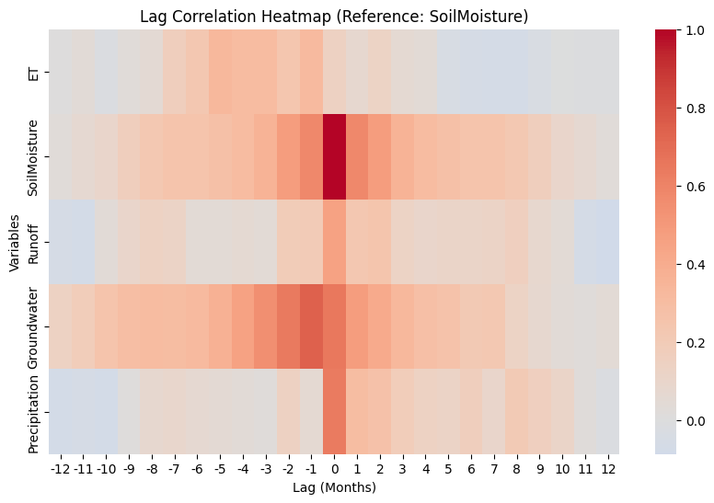
The lag correlation heatmap, using soil moisture as the reference variable, highlights how different hydrological components respond over time after removing seasonal effects. The results show that precipitation has the strongest correlation around zero lag, indicating that rainfall quickly influences soil moisture through rapid infiltration. Runoff also shows moderate correlation near zero lag, suggesting that surface runoff responds almost immediately once the soil becomes wet. Evapotranspiration displays positive correlation around zero to −1 month lag, indicating that higher soil moisture supports increased evapotranspiration. Groundwater shows a broader positive correlation between zero and +1 month lag, suggesting a slightly delayed recharge process as water gradually percolates from the soil to the groundwater system.

